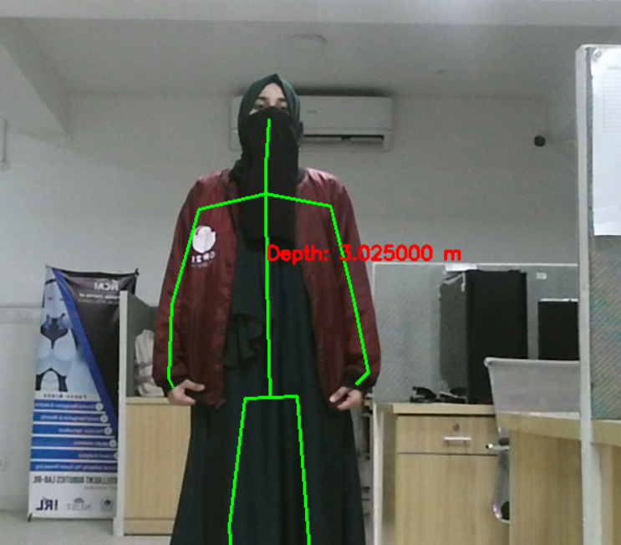

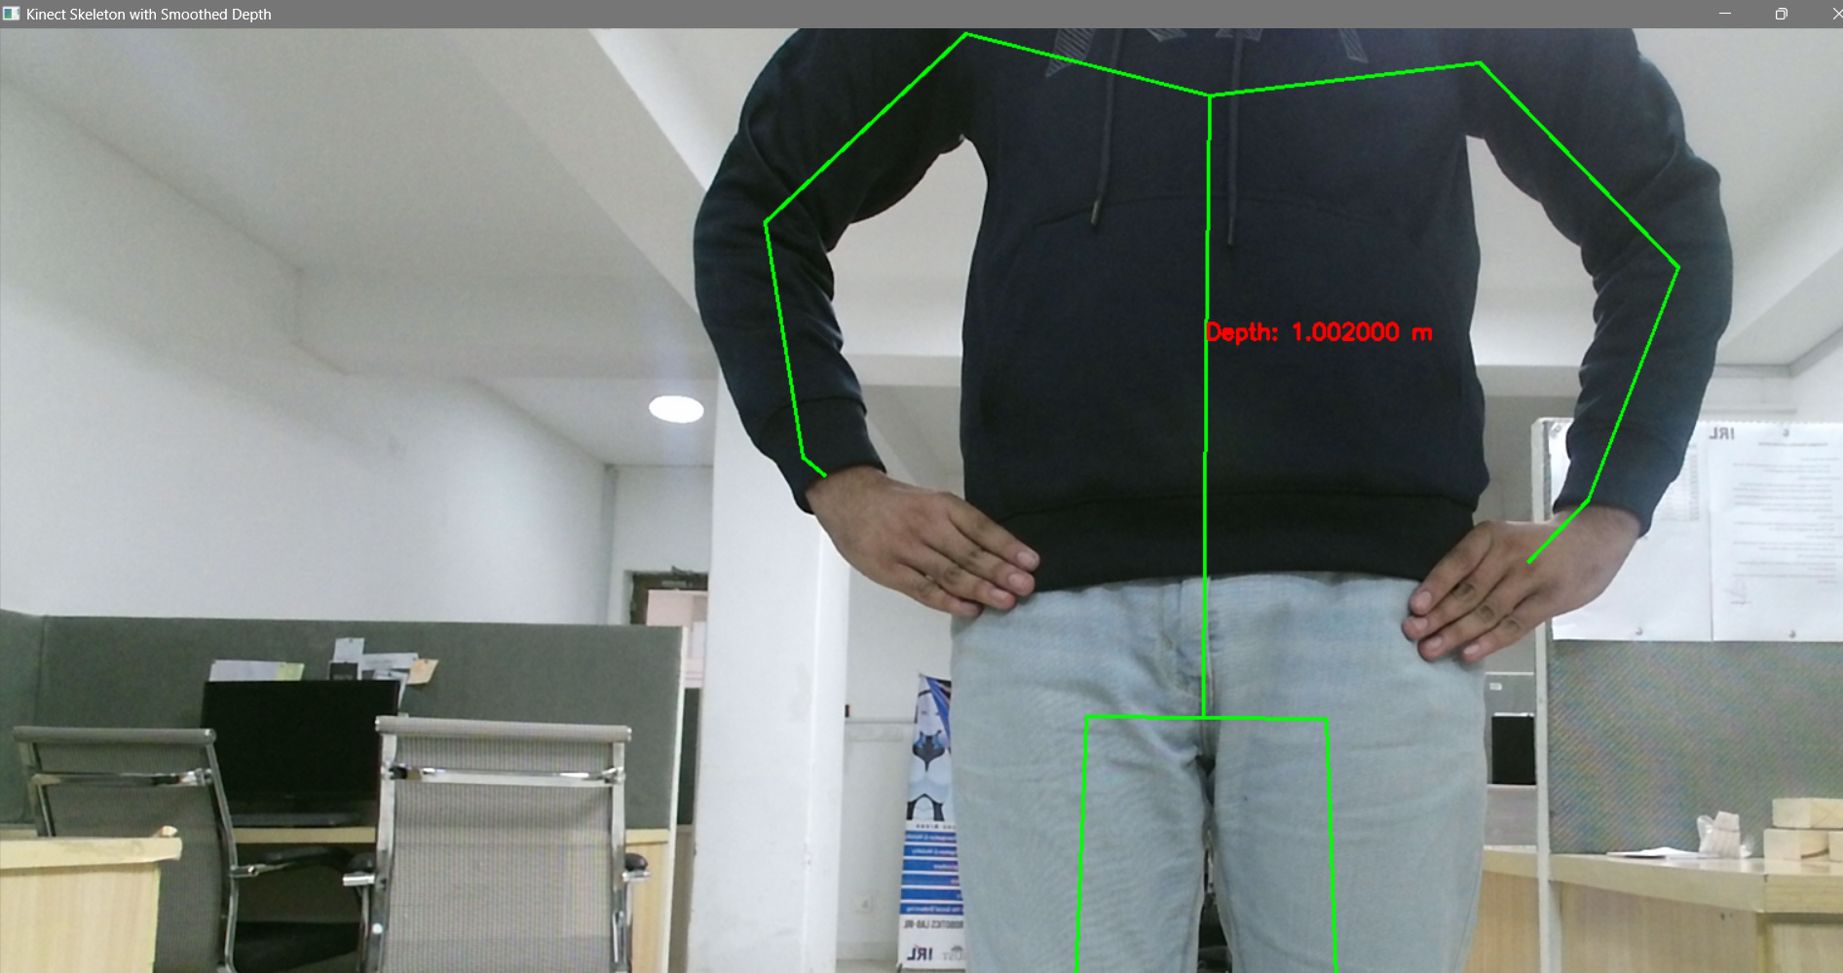

Tug test

